Graphs Worksheet

- Draw a simple, undirected graph that has 12 vertices, 18 edges, and 3 connected components. Why would it be impossible to draw G with 3 connected components if G had 66 edges?
- Draw the adjacency list and adjacency matrix representation of the undirected graph shown in the Figure below:
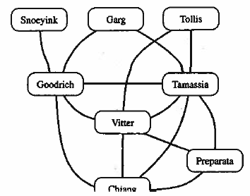
- Let G be a graph whose vertices are the integers 1 through 8, and let the adjacent vertices of each vertex be given by the table below:
Vertex | Adjacent Vertices
1 | (2, 3, 4)
2 | (1, 3, 4)
3 | (1, 2, 4)
4 | (1, 2, 3, 6)
5 | (6, 7, 8)
6 | (4, 5, 7)
7 | (5, 6, 8)
8 | (5, 7)

Assume that in a traversal of G, the adjacent vertices of a given vertex are returned in the same order as listed in the table above.
- Draw G.
- Give the sequence of vertices of G visited during a DFS traversal starting at vertex 1.
- Give the sequence of vertices of G visited during a BFS traversal starting at vertex 1.
- Explain why the DFS traversal runs in O(n²) time on an n-vertex simple graph that is represented with the adjacency matrix structure.
- Draw a simple, connected, weighted graph with 8 vertices and 16 edges each with unique edge weights. Identify one vertex as a “start” vertex and illustrate a running of Dijkstra’s algorithm on this graph.
- Draw a simple, connected, undirected, weighted graph with 8 vertices and 16 edges each with unique edge weights. Identify one vertex as a “start” vertex and illustrate a running of Kruskal’s algorithm on this graph.
- A simple, undirected graph is complete if it contains an edge between every pair of distinct vertices. What does a depth first search tree of a complete graph look like?

